# Lab for Introduction to Networking

This is the first lab for Introduction to Networking

## Outcome

This assignment will expose the user and give them the ability to explain the process a packet takes across the internet via the `traceroute` tool.

## Questions

Perform a Traceroute between source and destination on the same continent at three different hours of the day. Include a screenshot of the output you are using to answer the questions. On Windows use: `tracert` on Mac use: `traceroute`.

### Screenshot 1

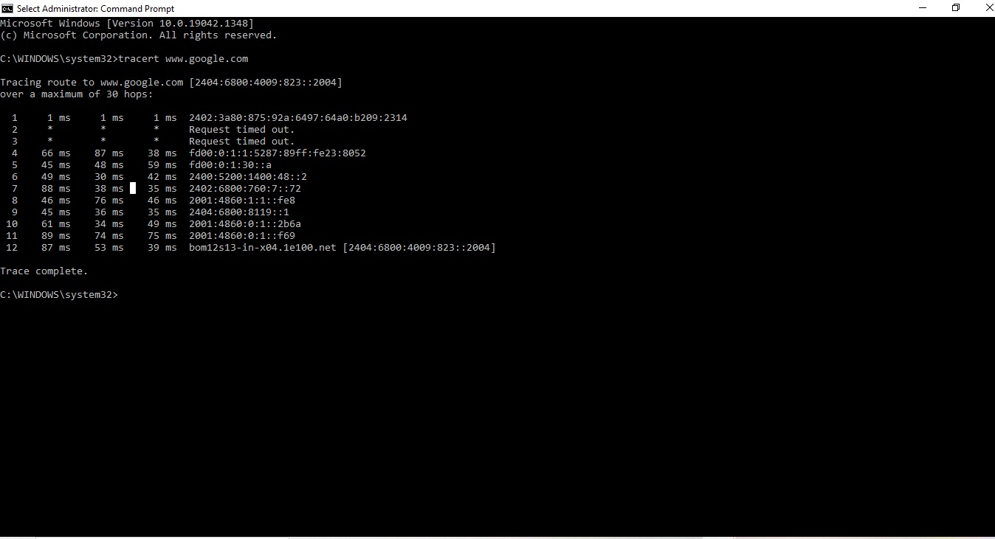

### Screenshot 2

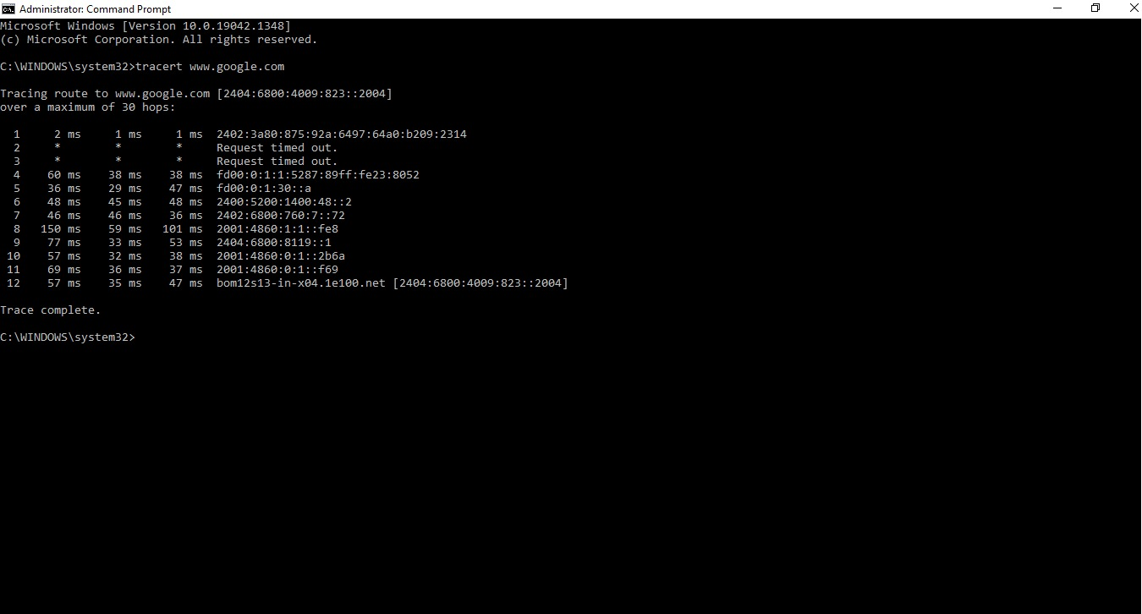

### Screenshot 3

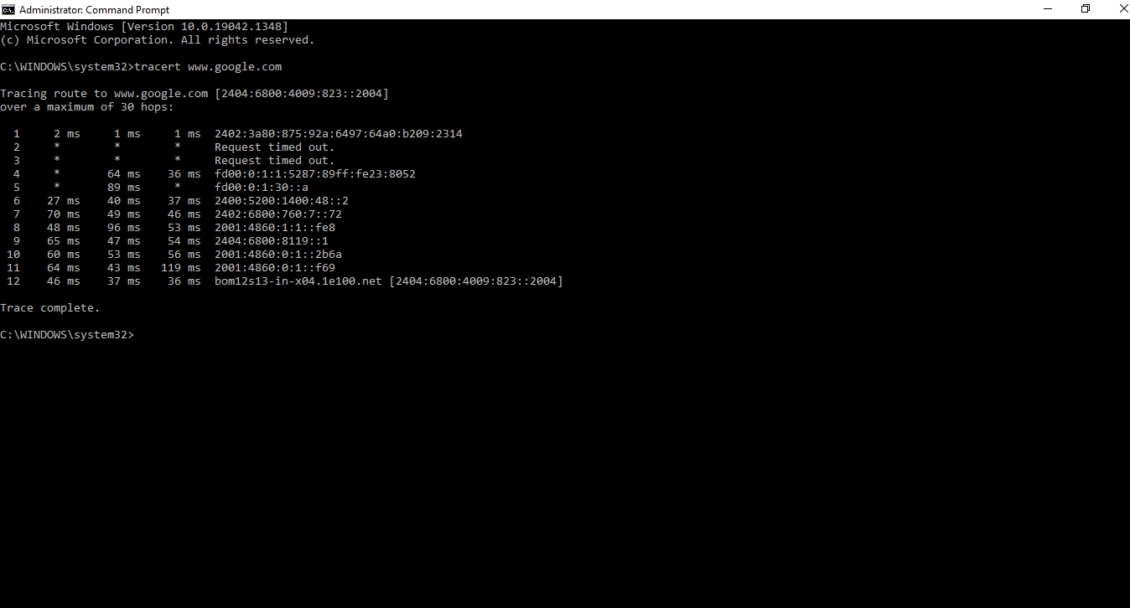

* Find the average of the round-trip delays at each of the three times of day.

i)

* Find the number of routers in the path at each of the three times of day. Did the paths change during any of the times?

i)

* Try to identify the number of ISP networks that the Traceroute packets pass through from source to destination. (Routers with similar names and/ or similar IP addresses should be considered as part of the same ISP.)

i)

### Screenshot 4

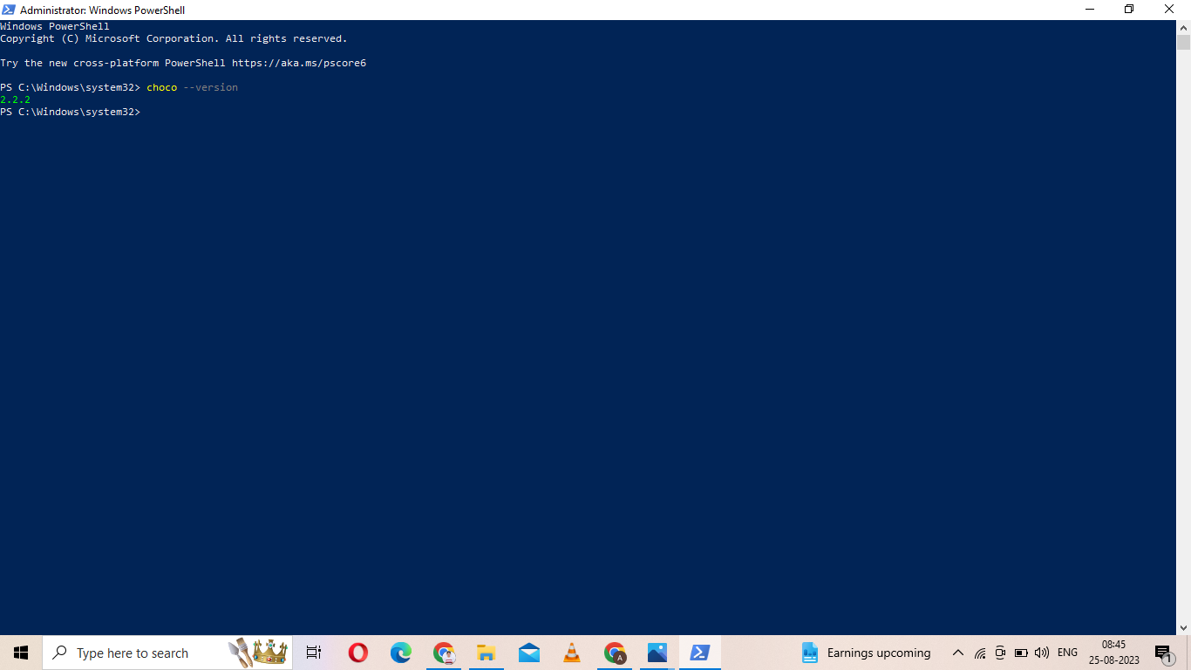

Using either Brew or Chocolatey install Wireshark - launch Wireshark and place screenshot here showing its installation

## Deliverable

Download this template. In your local repo create a sub-folder named **week-03** under the **itmo-540** folder.

Due on Wednesday the 13th 6:00 PM Central Standard Time.

Kurose, James F.; Ross, Keith. Computer Networking (p. 72). Pearson Education. Kindle Edition.